Write a program that will read in two numbers in as strings. Your program should store the digits in the number as a sort linked list. Your program should then merge the two linked list together in sorted order into a new linked list without changing the original two linked list. Your merge algorithm needs to run in O(n+m) time with n and m being the length of the two linked lists. You merge algorithm must be recursive.
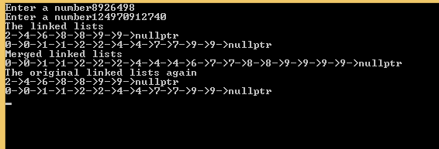

Given the definition for a node in a linked list,

struct node {
int data;
node *next;
};

and given a linked list p with unique values which are sorted in ascending order and a linked list odd and even which are nullptrs write a function

node* odd_even(node *p,node *&odd,node *&even)

that seperates p into two linked list, odd which is an ascending linked list of odd values and even which is an ascending linked list of even values.
- odd_even must be a destructive function meaning that no new nodes are allocated and the original list p cannot be reconstructed.

Examples
if p points to the linked list [ 1 3 5 6 8 9 ] then odd should be [ 1 3 5 9 ] and even should be [ 6 8 ] and p should be nullptr.

if p points to the linked list [ 6 14 18 ] then odd should be nullptr and even should be [ 6 14 18 ] and p should be nullptr.

Should be call like this
p = odd_even(p,odd,even)

Do not use arrays. Do not use vectors. Do not strings. Do not use globals. Do not use static variables. Do not use the STL.

Given the definition for a node in a linked list,

struct node {
char data;
node *next;
};

and given a linked list p write a function

node* org(node *p);

this function should move the nodes around so that will the nodes that contain a uppercase character come before the nodes with a lowercase number.
- org must not allocate memory for new node. You must change the next pointers in all the nodes so that the list is in a different order.

Examples
if p points to the linked list [ A b c C c a ] p should be [ A C b c c a] (note the order of the chars don’t matter what is important is the uppercases come first).

Should be call like this
p = org(p);

Do not use arrays. Do not use vectors. Do not strings. Do not use globals. Do not use static variables. Do not use the STL.

